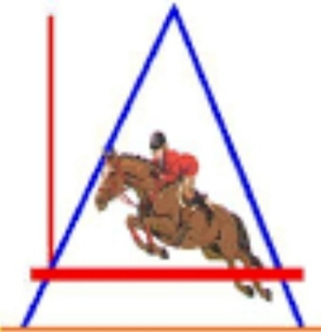
LOCHSIDE ARENA SOW JUMPING LEAGUE 16th JULY 2022
On Saturday 26TH November 2022
At Lochside Arena
Starting at 10AM prompt
Class fees are £7 to non-members and £4 for Lochside Arena Members
£10 to join the league
All entries to be returned to Amy Fraser, 19 Columbia Place, Stornoway, HS1 2TN no later than Saturday 23rd November 2022
Payment can be made on PayPal using friends and family to lochsidearena@gmail.com
Class No | Horse’s Name | Height | Rider’s Name | Fee
 |  |  | TOTAL

Parent’s Name (if under 18 years old)
Address
Child’s Age
Contact No
Email Address

